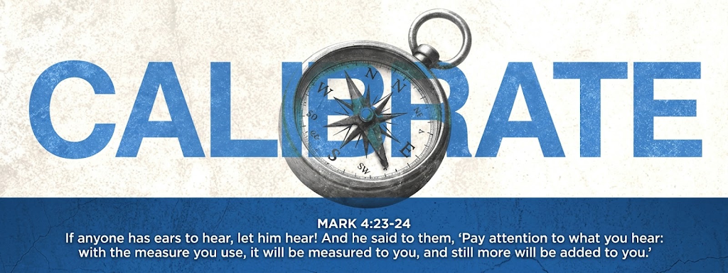
Connect Group Calibrate Part 2
Mark 4:23-24 "If anyone has ears to hear, let them hear!" And he said to them, “Pay attention to what you hear: with the measure you use, it will be measured to you, and still more will be added to you."
Connect Group:
- Choose ONE EVENING a week to host your connect group.
- Ask each member of your connect group to bring their Bible.
- If you wish, you can take communion together again.
WELCOME
Welcome: Welcome each group member.
Icebreaker: Choose one of the following topics and discuss it:
a) Are you naturally more like a "thermometer" (that merely takes on and reflects the temperature and mood of a room) or a "thermostat" (that controls and changes the atmosphere and temperature in a room)? Tell the group about a situation where your mindset changed the entire atmosphere around you.
b) Think of a time when things looked very bad or dark to you, like a figurative "prison". What role has music (worship) or prayer played in getting you out of that negative state of mind?
WORD
Prayer: Open with prayer. (Give everyone an opportunity)
Read: CORE TEXTS FOR TODAY:
Colossians 3:1-2
Since then, you have been RAISED with Christ, set your hearts on things above, where Christ is … SET (calibrate) your minds on things above, not on earthly things …
Romans 12:2
… Do not CONFORM to the pattern of this world but be transformed by the RENEWING of your mind. Then you will be able to TEST (measure) and approve what God’s will is—his good, pleasing and perfect will.
Acts 16:25-26
… About midnight Paul and Silas were PRAYING and SINGING hymns to God, and the other prisoners were LISTENING to them. Suddenly there was such a violent earthquake that the foundations of the prison were SHAKEN. At once all the prison doors FLEW OPEN, and everyone’s chains CAME LOOSE.
Discuss the following in your Connect Group:
This week we delve deeper into the theme of calibration. Calibration is defined as the fine-tuning of an instrument according to a given standard so that it can provide reliable and accurate measurements. We are specifically looking at how we can apply "Atmosphere Control" in our lives; in other words, learning to act like a thermostat that influences the environment, rather than a thermometer that merely reflects the environment's temperature.
Paul exhorts us in Colossians 3:1-2 that, as resurrected believers, we must calibrate or set our minds on things above, and not on earthly things. Romans 12:2 further reminds us that we should not be conformed to this world, but that our minds must be renewed so that we can test and measure what God's perfect will is. This means the measure we use must change so that it aligns with the heavenly standard, rather than the earthly one.
The wonderful power of atmosphere control is vividly seen in the story of Paul and Silas in Acts 16. While they were in a dark prison, they completely changed the atmosphere; around midnight they prayed and sang to the glory of God, and suddenly an earthquake opened the doors, and everyone's chains came loose.
Three practical ways we can control or calibrate the atmosphere:
- Worship: As it says in 2 Chronicles 20:21-22, the moment the people began to praise and sing to the Lord, He caused the enemy's armies to start fighting among themselves.
- Speak the Word: Proverbs 18:21 warns that the tongue has power over life and death, and that we must live with the consequences of our words.
- Fasting and Prayer (Tongues): According to Isaiah 58:6, the right type of fast breaks yokes and sets the oppressed free. Acts 4:31 shows how fervent prayer can shake a place and fill people with the Holy Spirit to boldly speak God's Word.
Read Today's texts again and discuss them:
a) In Romans 12:2 we are commanded not to conform to this world. Why do you think it is sometimes easier for us to act as a "thermometer" that tunes into worldly negativity, instead of acting as a changed "thermostat" that brings the good and perfect will of God into a situation?
b) Reflect on the 3 practical ways to control the atmosphere: Worship, Speaking the Word, and Fasting and Prayer. Which of these areas are you already applying successfully, and which one requires the most urgent "fine-tuning" (calibration) in your spiritual walk this week?
WORSHIP & WORKS
Worship - https://woordenlewe.com/connect-worship/ Make time to worship God today. Use the playlist on our Woord en Lewe website under Connect or use the worship from Sunday's service.
APPLICATION and questions:
Now take Communion together as a Connect Group:
Love for God, Love for People. As a Connect Group, spend about 5 minutes in silence before you adjourn, and let each member answer the questions below for themselves. Create a peaceful atmosphere and allow the Lord to speak to each one individually.
- Examine your direction: Test your thoughts. Is your attention and mind truly set on things above, as Colossians 3:1-2 asks, or are you allowing earthly things to alter your measure?
- Reflect on your words: Confess in silence anywhere your tongue might have spoken death rather than life recently, remembering the warning of Proverbs 18:21. Make a firm decision to speak life over your situations from today onward.
- Examine your worship: If you find yourself in a "midnight hour" or dark season in your life, is your immediate reaction to praise and pray to God, just as Paul and Silas did (Acts 16:25-26)?
- Ask God for boldness: Pray and ask God to fill you with the Holy Spirit, so that you can speak the Word with boldness and so that your prayers will break chains and bring freedom (Acts 4:31, Isaiah 58:6).

